

**FOOD ORDERING AND MANAGEMENT SYSTEM**

**CSE3001 - SOFTWARE ENGINEERING**

By

Shaik Imran - 20BCE0009

Rudraksh Tandon - 20BCE0283

Tanmay Vyas - 20BCE0755

Raj Gupta - 20BCE2760

Jattin Jaggi - 20BCT0082

Under the guidance of

Dr. Sivaprakash S.

School of Computer Science and Engineering

Vellore Institute of Technology, Vellore

**PROJECT ABSTRACT**

Our project is a web application with the aim to provide an entire online ordering section. Customers

Will be allowed to select a restaurant and then go through the menu of that restaurant and choose

the food items they wish to have. The user could also specify the time they want to pick up

their order.

We will use HTML, CSS, and JavaScript for the front end and NodeJS and MongoDB for the backend and database respectively. Users will have the facility to Create, Manage their accounts. Restaurants within the campus are displayed, and users can select one among them. Once the user

selects the restaurant they could select items they require and the pickup time on which the user would

reach out to them for their respective orders. Users can also Update and Delete their order within

specific closure of time.

**EXISTING SYSTEM**

In the present scenario, the traditional food ordering procedure is not efficient enough for restaurants, as they have to deal with the crowd, in their restaurant. The Existing methods can be classified into paper-grounded and online based.

For paper-based work, the waiter comes and pens down foods that customers order and pass the food list containing paper to the chefs or cooks in the kitchen for further process. From the owner’s point of view maintaining data records and the accounts in the physical file is cumbersome and tedious work to do. And also, it is full of risk as anyone can access it and modify the data. In this method, time and physical work is required, among which time is something that no one has in an ample amount

For the Online based scenario, even though we can tackle the problem of data access and modification, recent Online ordering systems like Swiggy and Zomato still have the problems like food orders may not arrive by the time we were expecting, the Quality of food may differ and the person who delivers food may not be trustworthy.

**ADVANTAGES OF THE PROPOSED SYSTEM**

This system is a bunch of benefits from various points of view. This online application enables the end-users to register to the system online, select the food items of their choice from the menu list, add the possible pick-up time, and order food online. Also, the payment can be made at the time of picking up delivery depending upon the customer’s choice and convenience.

The selection made by the customers will be available to the restaurant reception or to the person handling the work assignment. Now this same person will assign the orders to the chef to be completed within the requested amount of time.

The review system in the application which describes the review of each restaurant helps in ensuring food is safe to eat and will not lead to outbreaks of foodborne illness among consumers. One of the various benefits of this system especially in the traditional system is that if there is a rush or a huge crowd present in the restaurant then in that case sometimes the unavailability of tables cuts down the restaurant’s customers. Also, there will be chances that the waiters are unavailable as they are busy handling others, so the customer can directly order the food online by using this application and pick it back up by desired time.

**MODULE DESCRIPTION**

1. **Authentication module**

There will be a login option for the Student and the Admin, and authentication will be done using the User-Id and the password. The User-Id and password would be strings.

If someone enters the wrong details, the message of invalid credentials will pop up.

1. **Web Ordering System module**

This module provides the functionality for students to place their orders and supply necessary details. The students will be provided with the following functionalities:

• Create an account.

• Manage their account.

• Log in to the system.

• Navigate the restaurant’s menu.

• Select an item from the menu.

• Add an item to their current order.

• Review their current order.

• Remove an item/remove all items from their current order.

• Provide payment details.

• Place an order.

• Receive confirmation in the form of an order number.

1. **Menu Management System module**

This module provides functionality for the Admin only. It will not be available to the students. Using a graphical interface, it will allow an Admin to manage the menu that is displayed to users of the web ordering system:

• Add /update/delete food items to/from the menu.

• Update the price for a given food item.

• Update additional information (description, photo, etc.) for a given food item.

Before customers can actually use this system, the functionality provided by this component will have to be configured first. Once the initial configuration is done, this will be the least likely used component as menu updates are mostly seasonal and do not occur frequently.

1. **Order Retrieval System module**

It is designed to be used only by restaurant employees (admins), and provides the following functions:

• Retrieve new orders from the database.

• Display the orders in an easily readable, graphical way.

**SOFTWARE REQUIREMENTS**

* Operating system: Windows 7 or above
* Web browser
* Integrated development environment - Visual Studio Code

**SYSTEM ARCHITECTURE**

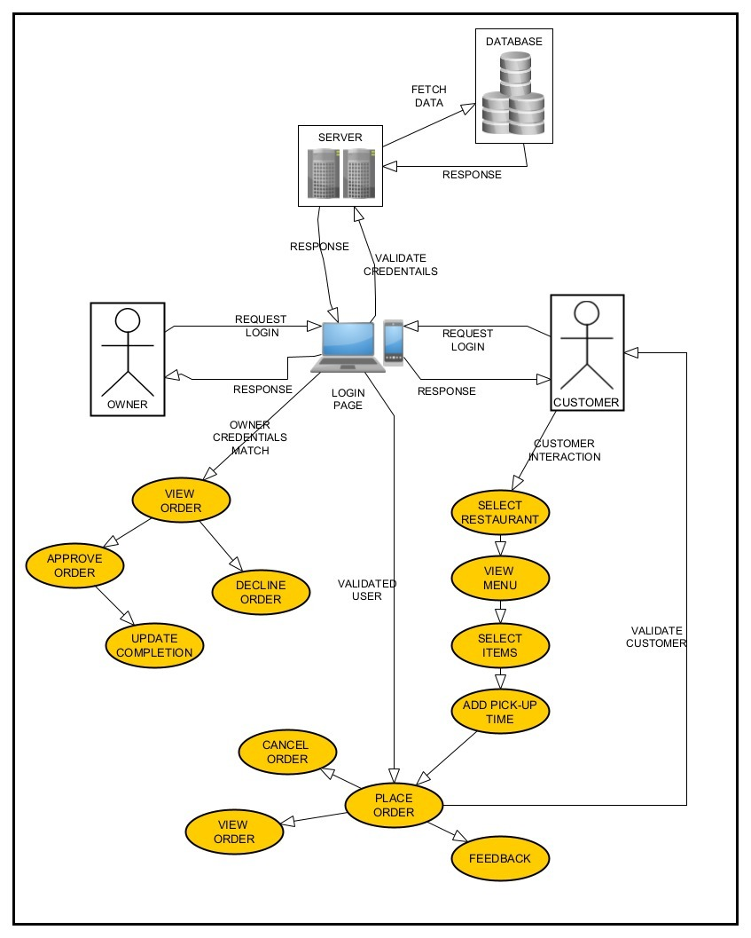

**USE CASE DIAGRAM**

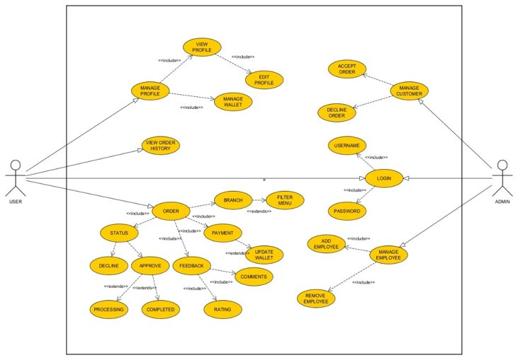

**CLASS DIAGRAM**

